Project Planning Phase
Date | 4 October 2026
Project Name | Automated Network Request Management
Maximum Marks | 5 Marks
Project Planning Template (Product Backlog, Sprint Planning, Stories, Story points)
Product Backlog, Sprint Schedule, and Estimation (4 Marks)
Use the below template to create product backlog and sprint schedule
Sprint | Functional  Requirement (Epic) | User  Story  Number | User Story / Task | Story Points | Priority | Team Members
Sprint-1 | Backend Setup | USN-11 | As an administrator, I can store request data in a custom table (u_database_table) with the required fields and an Approval Request related list. | 3 | High | Pentareddy Ruhin
Sprint-1 | Request Submission | USN-1 | As a requester, I can open the Network Request item on the Service Portal and fill in the request form (7 variables). | 3 | High | Pentareddy Ruhin
Sprint-1 |  | USN-2 | As a requester, I can choose the Type of Connection (New or  Existing) and see the Existing ID field only when I choose Existing. | 2 | Medium | Pentareddy Ruhin
Sprint-1 | Requester Information | USN-3 | As a requester, I want my email, user name and phone number filled in automatically when I select Opened on behalf of. | 3 | Medium | Pentareddy Ruhin
Sprint-2 | Automation | USN-12 | As an administrator, I want a Flow Designer flow that creates a record in u_database_table when a request is submitted. | 5 | High | Pentareddy Ruhin
Sprint-2 | Request  Confirmation | USN-4 | As a requester, I receive a request number after I click Order Now. | 2 | High | Pentareddy Ruhin
Sprint-2 |  | USN-5 | As a requester, I receive a confirmation email that contains my request number. | 3 | Medium | Pentareddy Ruhin
Sprint-2 | Approval | USN-6 | As an approver, I can see the pending approval for each network request. | 3 | High | Pentareddy Ruhin
Sprint-2 |  | USN-7 | As an approver, I can approve or reject the request. | 3 | High | Pentareddy Ruhin
Sprint-2 | Request Tracking | USN-8 | As an administrator, I can see each request with its Approval Status and Assigned to updated after the decision. | 5 | High | Pentareddy Ruhin
Sprint-3 | Maintenance | USN-9 | As an administrator, I can maintain the automation in Flow Designer without custom scripts and check each run in Flow Executions. | 2 | Medium | Pentareddy Ruhin
Sprint-3 | Fulfilment Visibility | USN-10 | As a network team member, I can view approved requests with full details so I can act on them. | 3 | Medium | Pentareddy Ruhin
Sprint-3 | Testing & Deployment | USN-13 | As the project owner, I can test the approve and reject scenarios end to end, check the email and flow logs, and document the solution. | 5 | High | Pentareddy Ruhin
Project Tracker, Velocity & Burndown Chart: (4 Marks)
Sprint | Total Story Points | Duration | Sprint Start Date | Sprint End Date (Planned) | Story Points  Completed (as on  Planned End Date) | Sprint Release Date (Actual)
Sprint-1 | 11 | 6 Days |  |  | 11
Sprint-2 | 21 | 6 Days |  |  | 21
Sprint-3 | 10 | 6 Days |  |  | 10
Velocity:
Imagine we have a 10-day sprint duration, and the velocity of the team is 20 (points per sprint). Let’s calculate the team’s average velocity (AV) per iteration unit (story points per day)
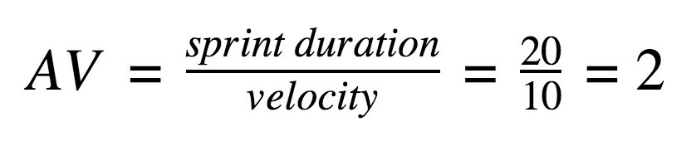
Velocity for this project: total story points = 11 + 21 + 10 = 42; number of sprints = 3.
Velocity = 42 / 3 = 14 story points per sprint.
With a 6-day sprint, average velocity per day = 14 / 6 = 2.33 story points per day.
Burndown Chart:
A burn down chart is a graphical representation of work left to do versus time. It is often used in agile software development methodologies such as Scrum. However, burn down charts can be applied to any project containing measurable progress over time.
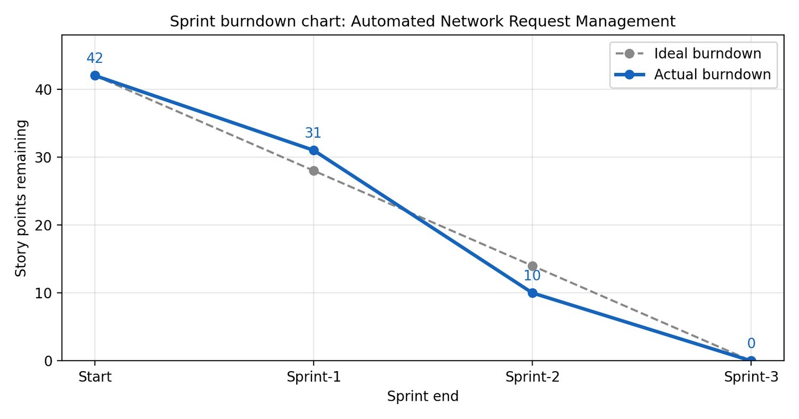
Burndown: 42 story points planned over 3 sprints (ideal 14 per sprint); all points completed by Sprint-3.
https://www.visual-paradigm.com/scrum/scrum-burndown-chart/ https://www.atlassian.com/agile/tutorials/burndown-charts
Reference: https://www.atlassian.com/agile/project-management https://www.atlassian.com/agile/tutorials/how-to-do-scrum-with-jira-software https://www.atlassian.com/agile/tutorials/epics https://www.atlassian.com/agile/tutorials/sprints https://www.atlassian.com/agile/project-management/estimation https://www.atlassian.com/agile/tutorials/burndown-charts

